Task on S3
- Create an S3 bucket and upload some objects to S3.
- Created a bucket in amazons3 with the name mydemo-bucket-13.
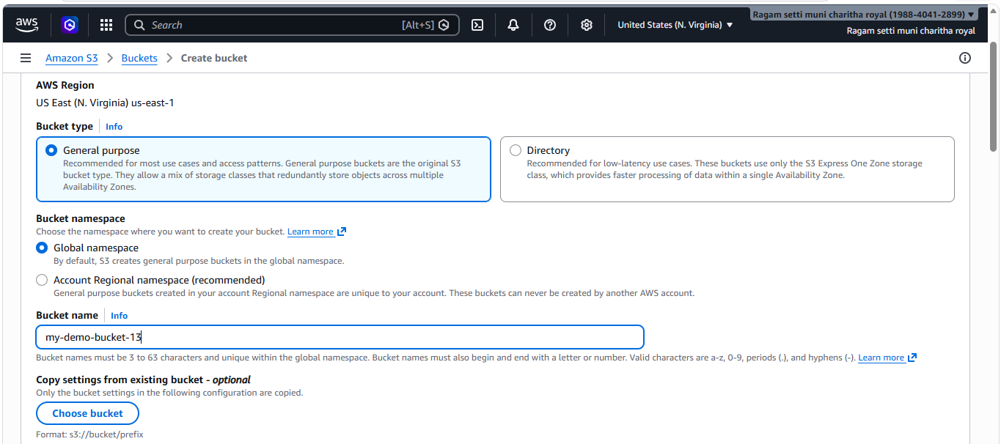
- Bucket created successfully.
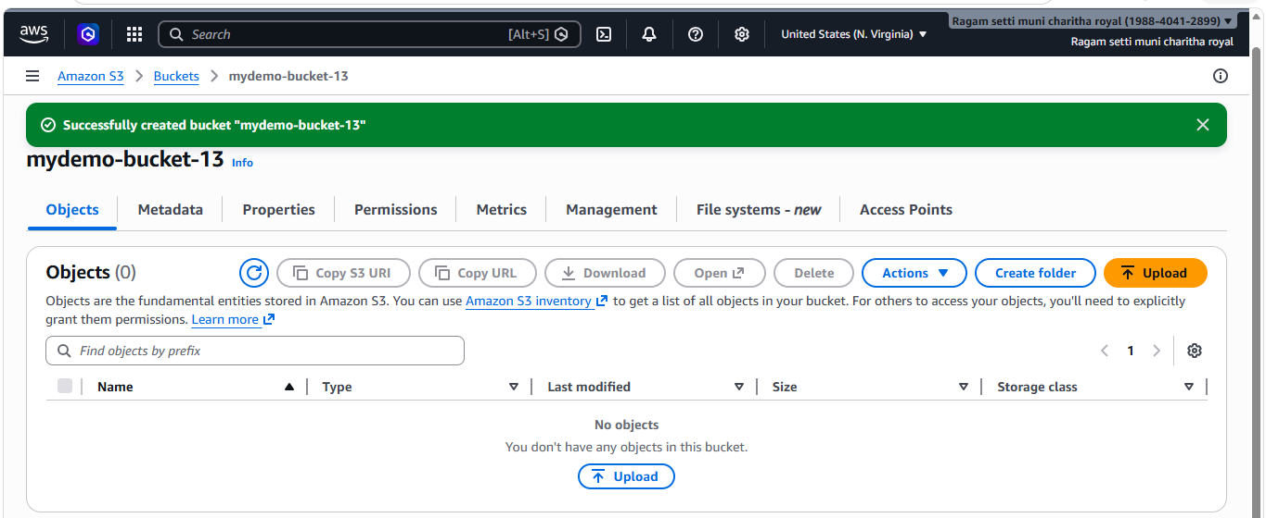
- And uploaded two objects(files) in the bucket.
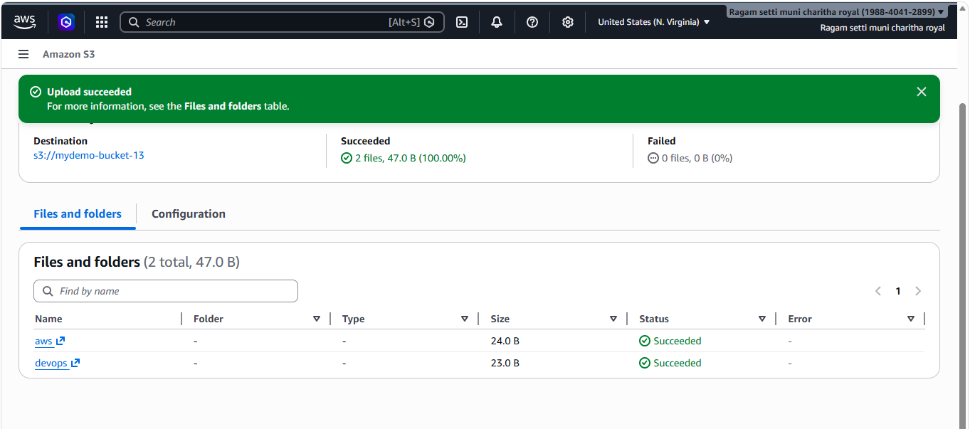
- Deploy a static website in the S3 bucket.
- Created a file
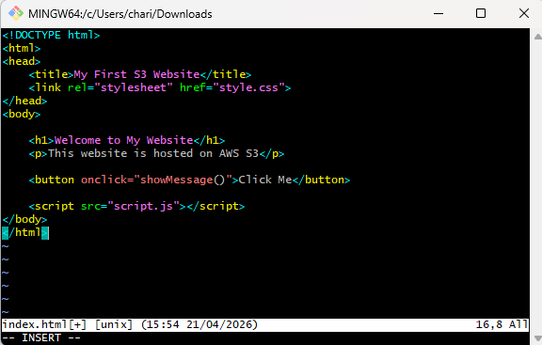
- Created a new bucket with the name mydemo-bucket-14 and gave public access.
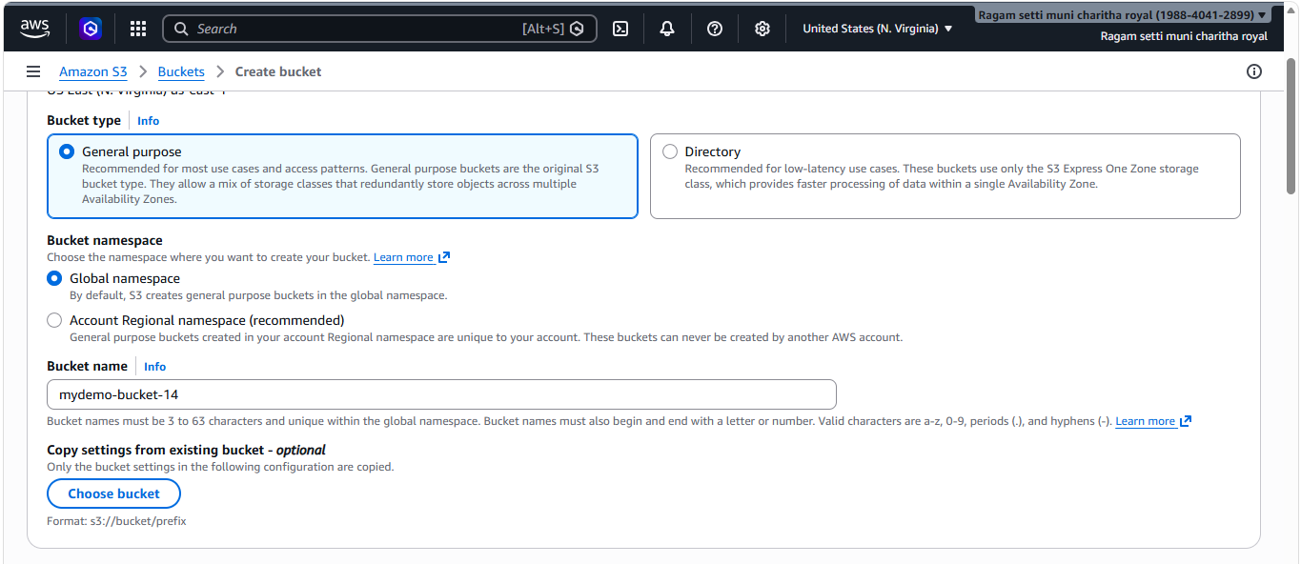
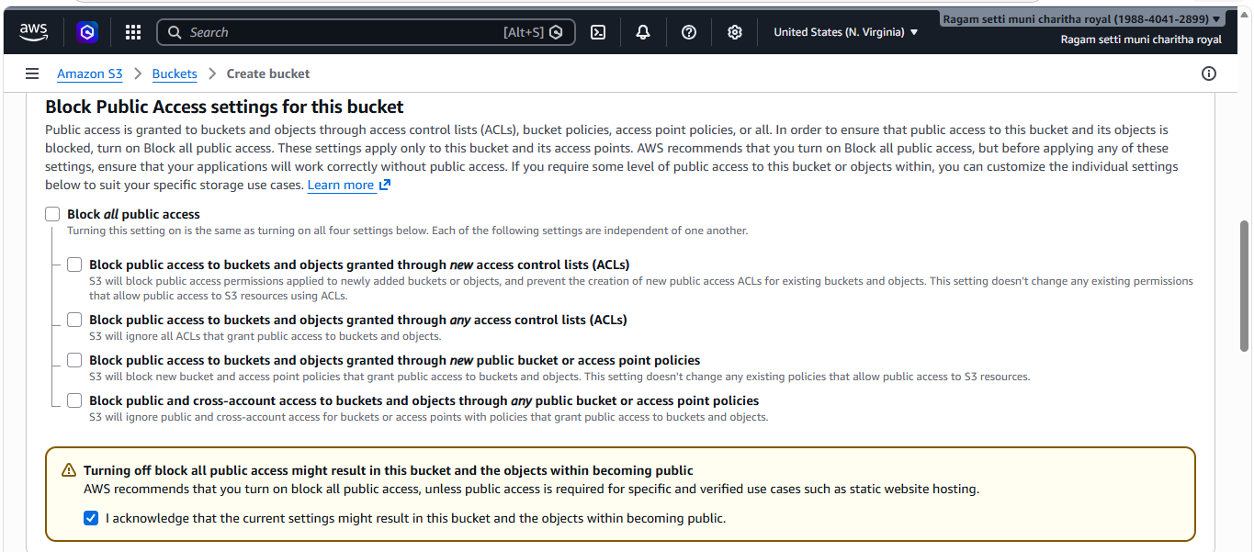
- And uploaded the file I created.
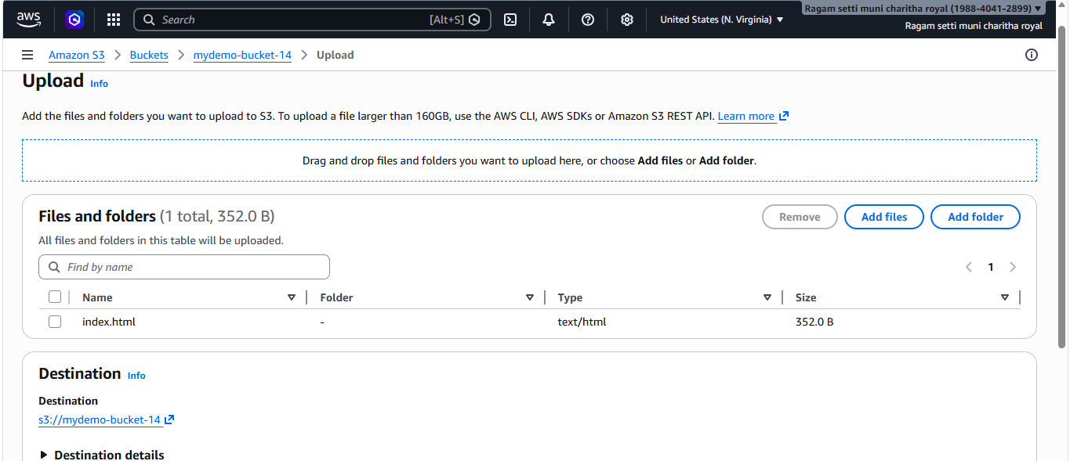
- Now I have enabled static website hosting
- First click on properties and scroll to static website hosting and click on
edit
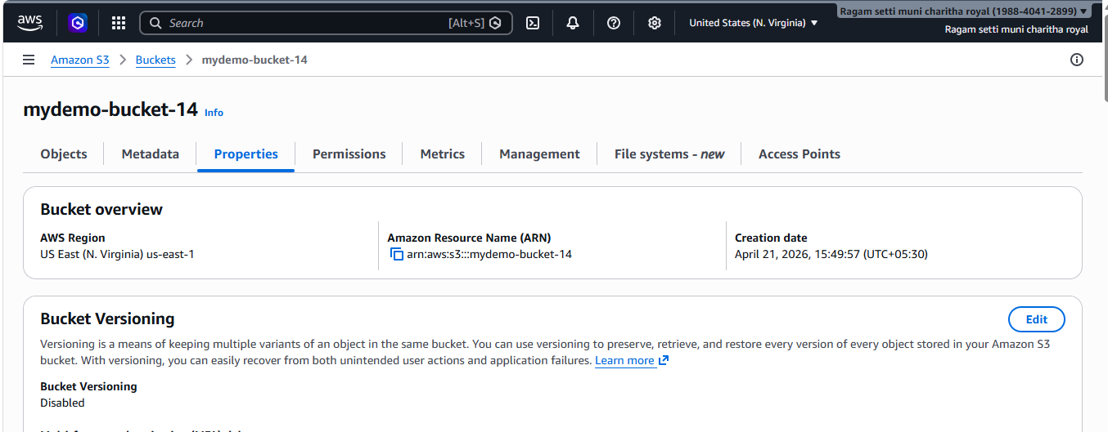
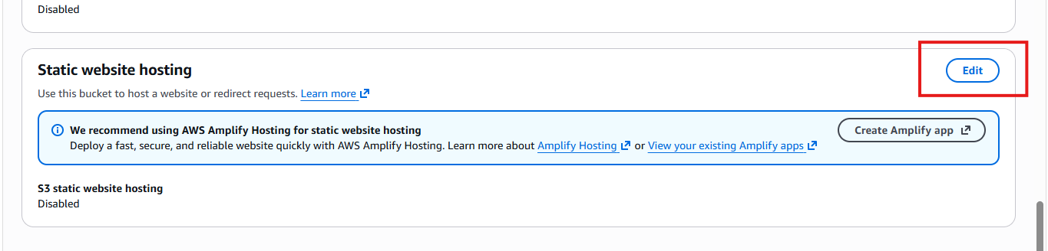
- Enable it
- Select Hosting type → Static website hosting
- Index document – given the name of doc
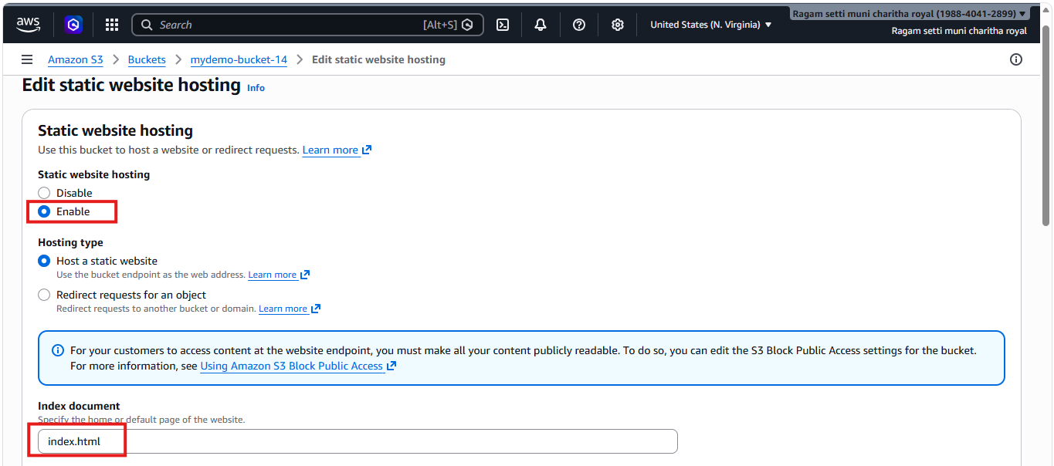
- We can able to get the website endpoint url
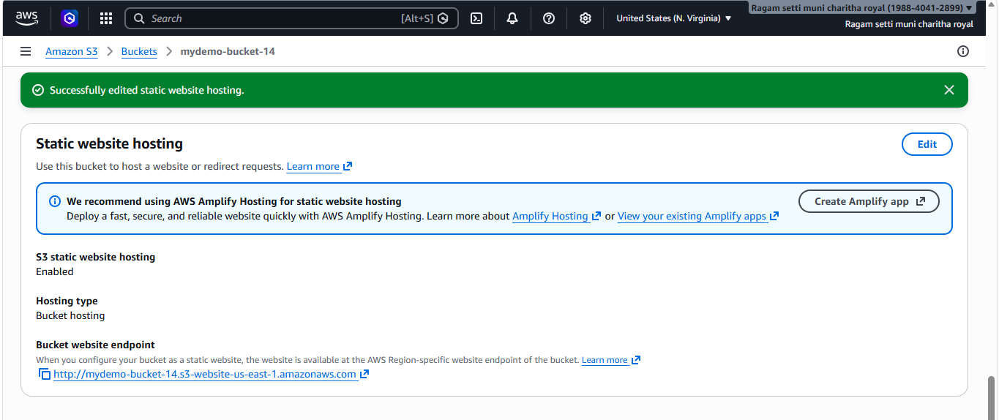
- Added bucket policy to allow
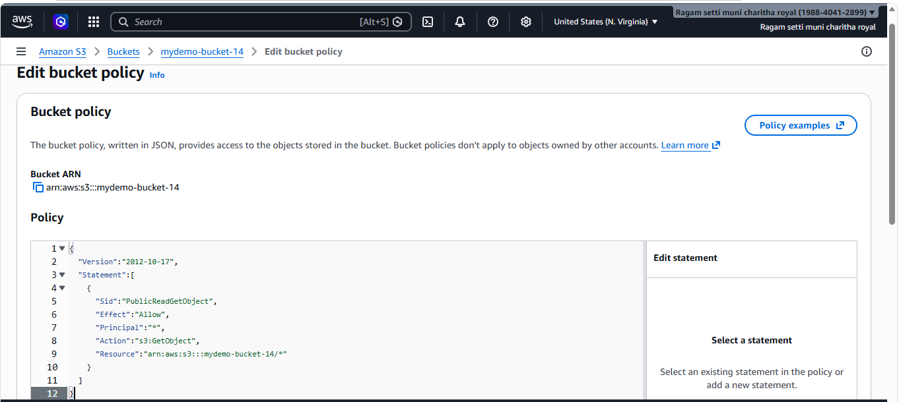
- I have copied the bucket website endpoint and tried to access that in web.
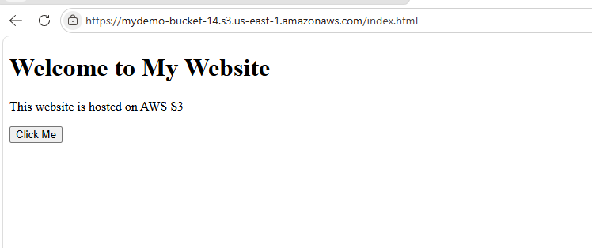
- Enable cross-region replication on S3 buckets.
Created a new bucket in Mumbai(new region) and gave public access and enabled bucket versioning.
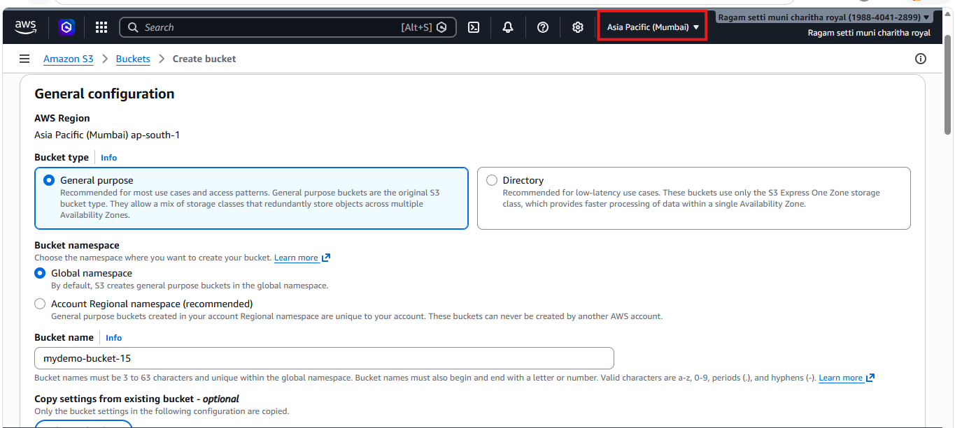
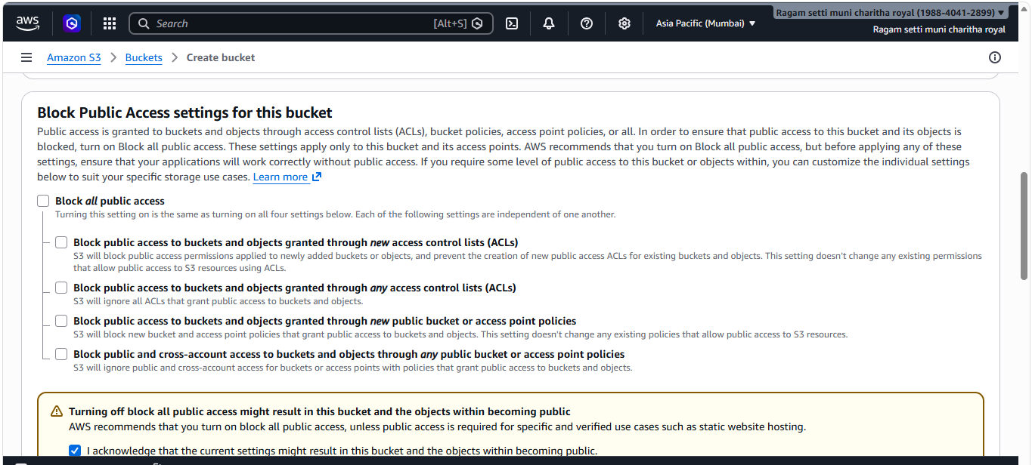
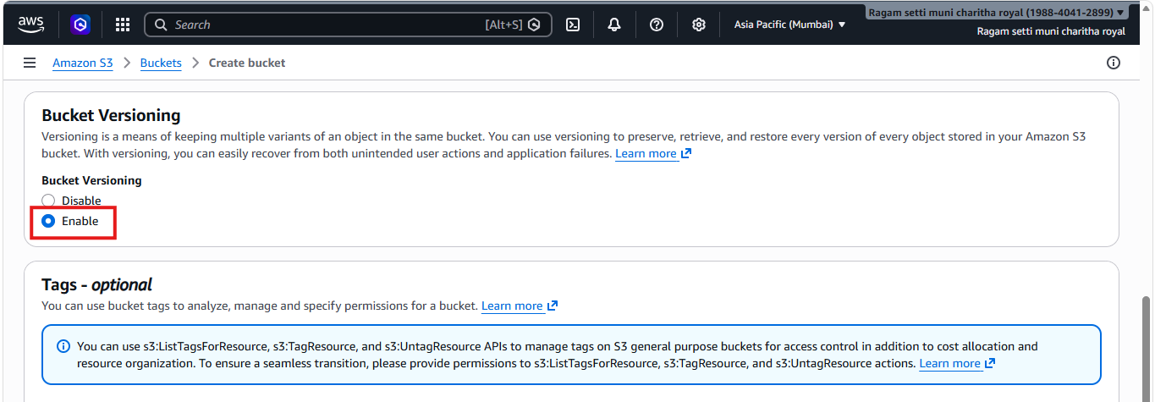
- Enabled bucket versioning in US East (N. Virginia), which is my default region.
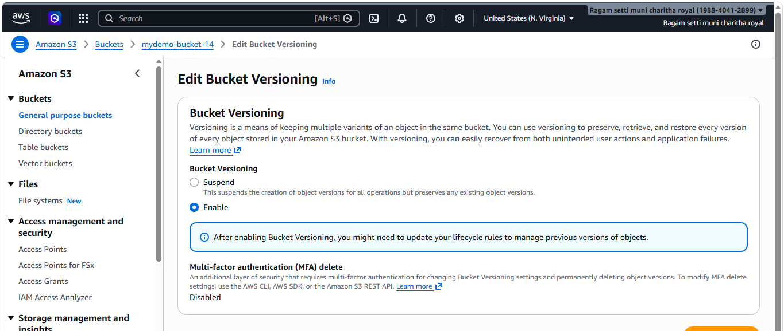
- In management I have created a replication rule and enabled status
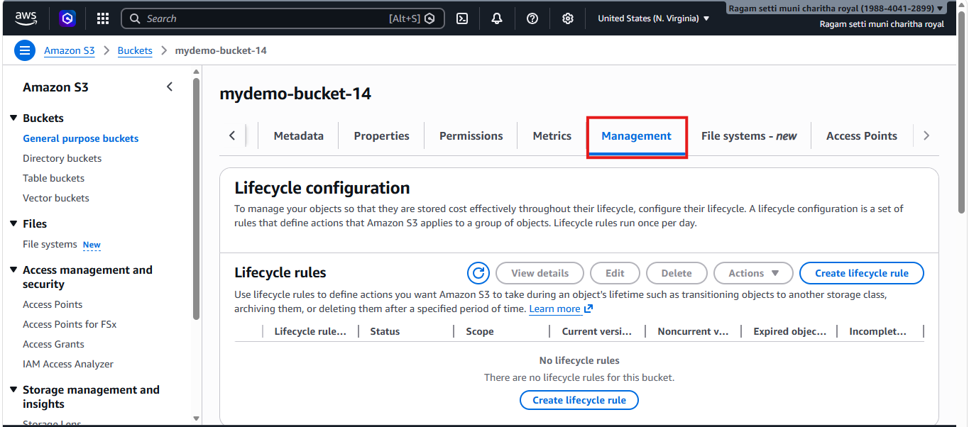
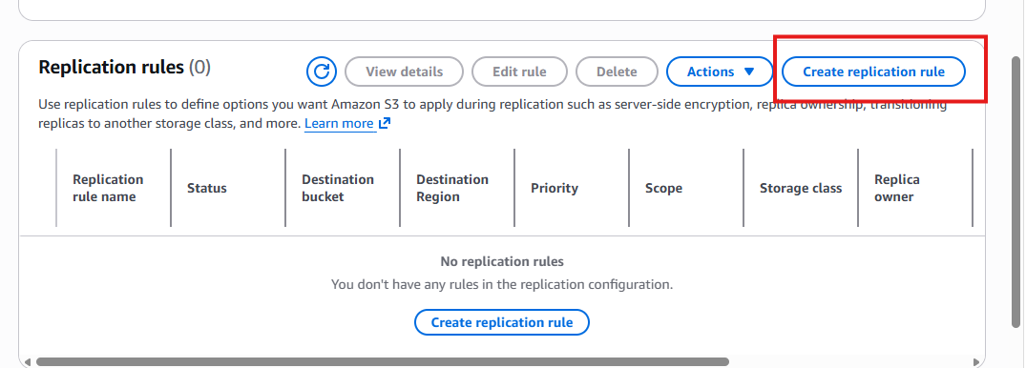
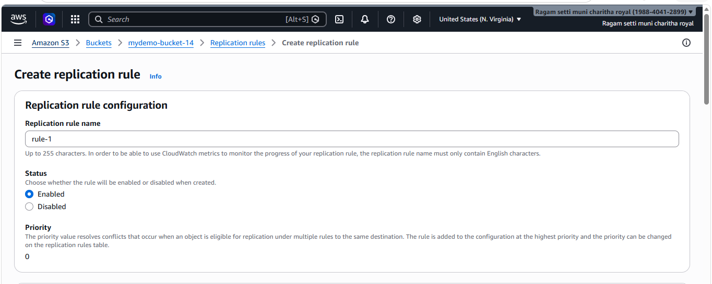
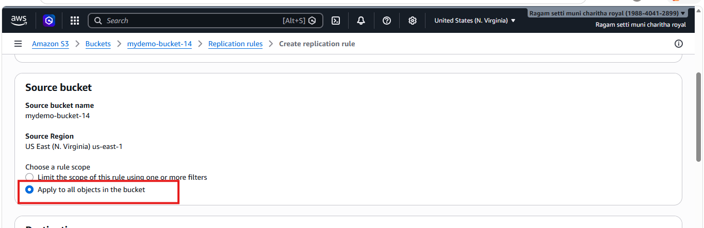
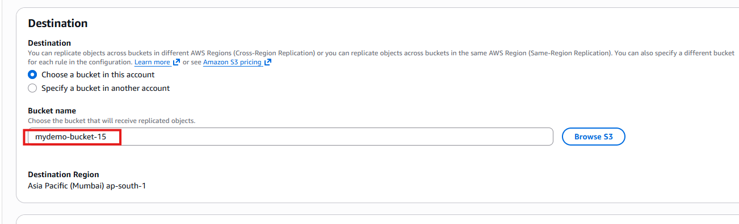
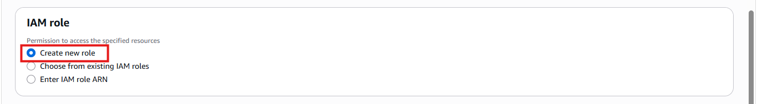
- Uploaded a file in US East (N. Virginia).
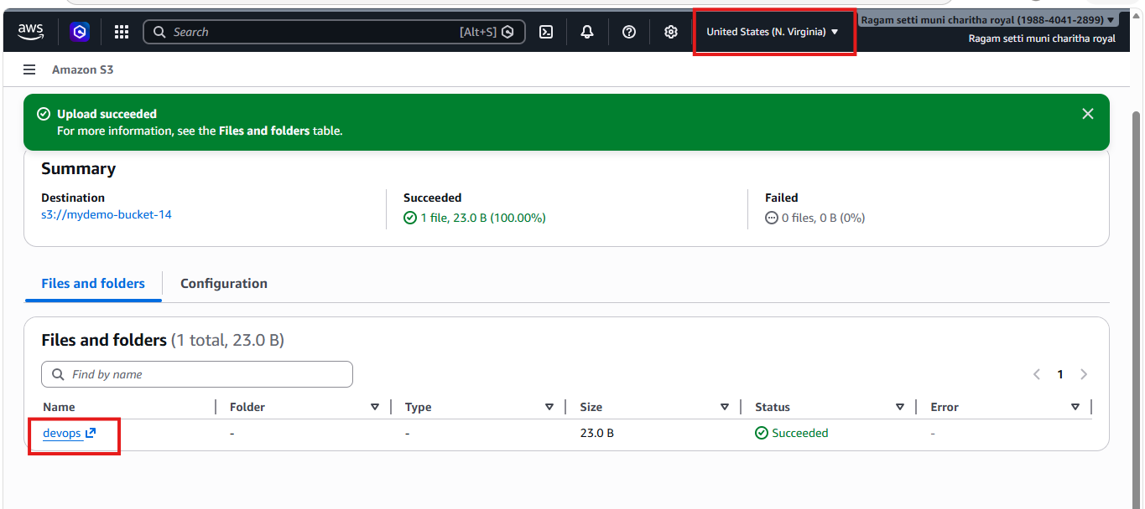
- The file which I have uploaded in US East (N. Virginia) that file is replicated in Mumbai region also.
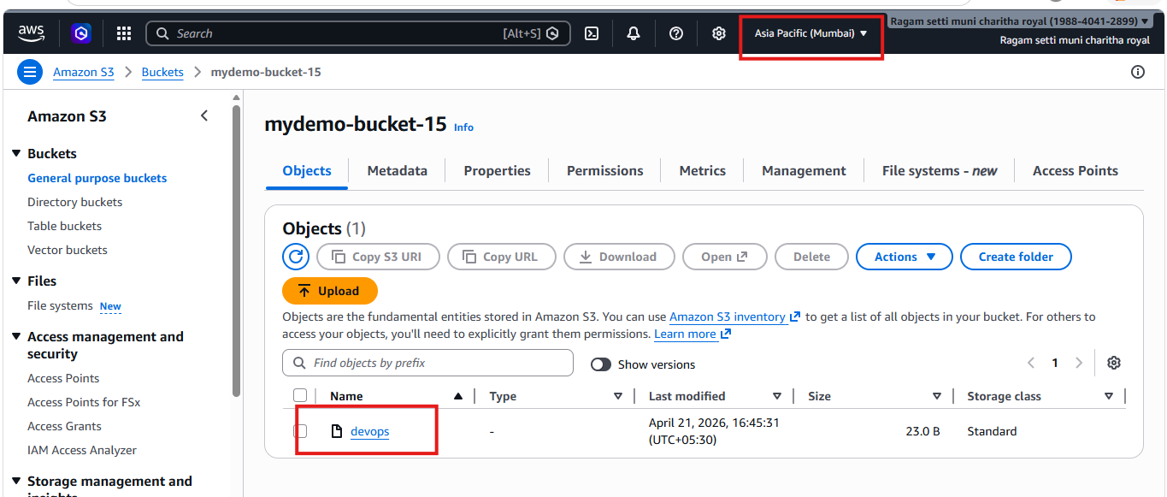
- Configure a bucket policy so only the Admin user can see the objects of the S3 bucket.
- I have administration access and I gave bucket policy in that bucket
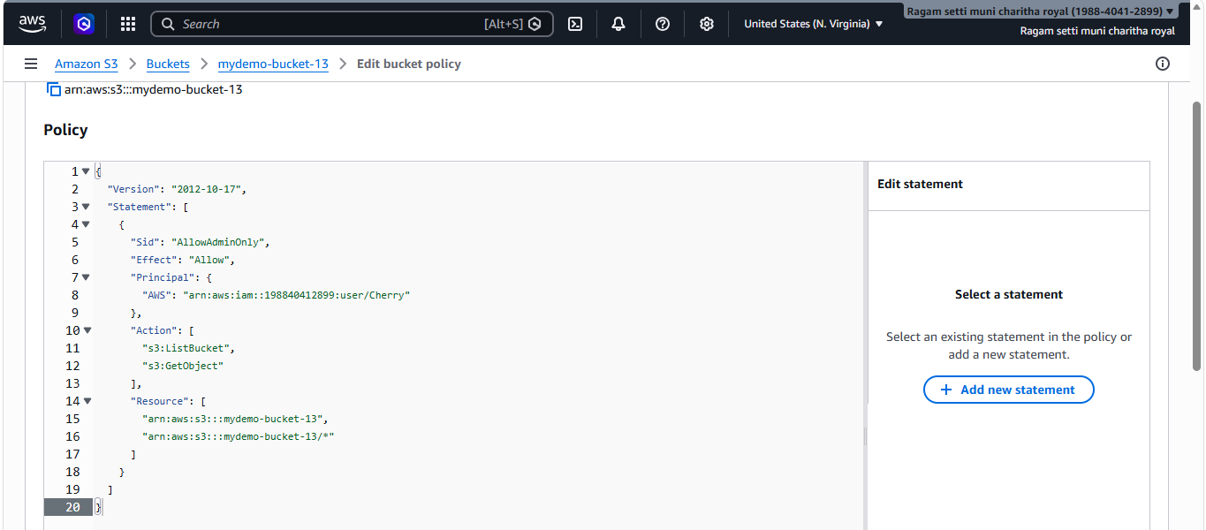
- After giving bucket policy, I checked with user which have administration access it worked successfully
- And tried with another user which is not having administration access it didn’t worked.
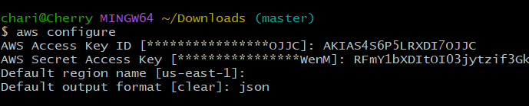
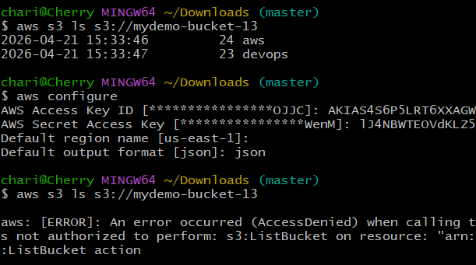
5.Set up lifecycle policies to automatically transition or delete objects based on specific criteria.
- First go to s3 bucket
- click management
- click on create lifecycle
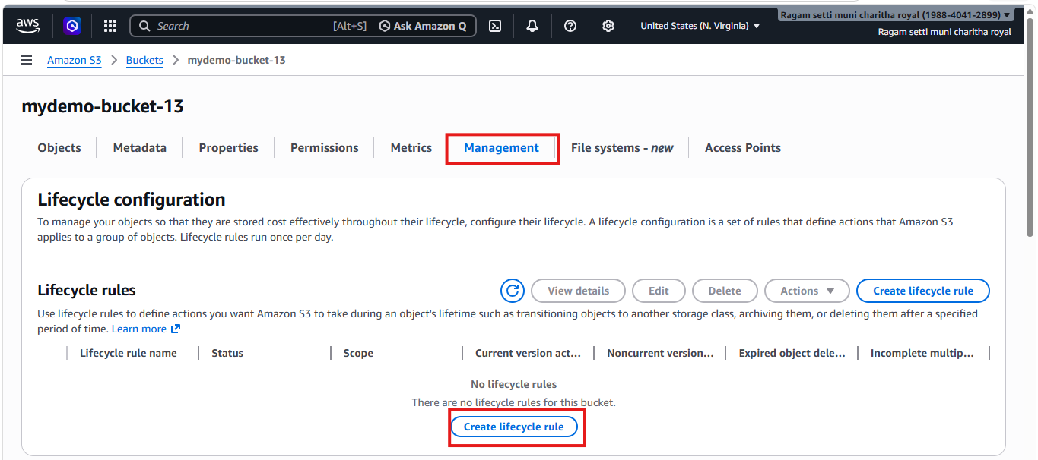
- Give the rule name
- Choose a rule scope
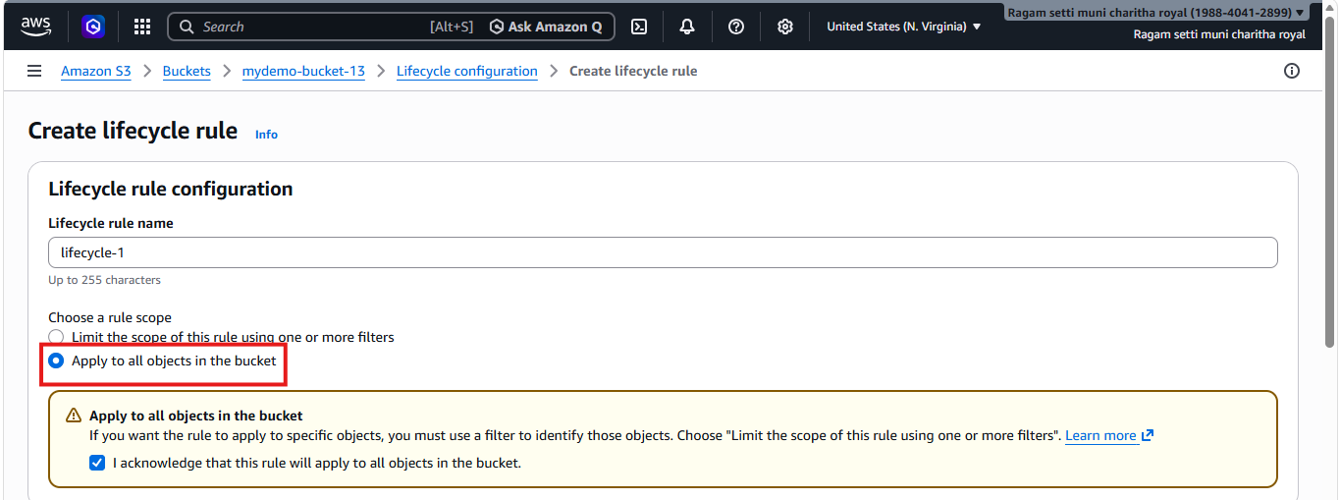
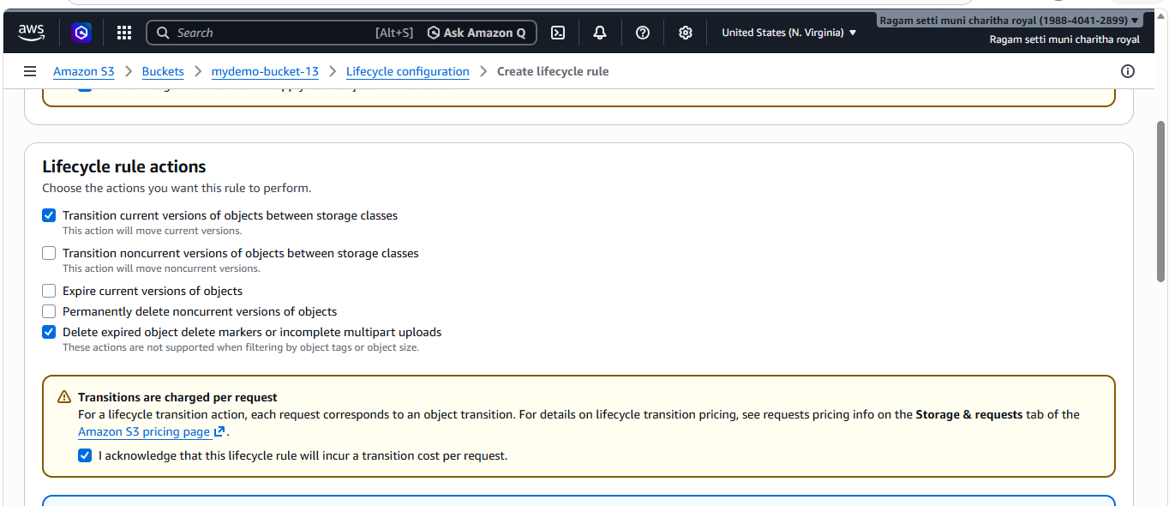
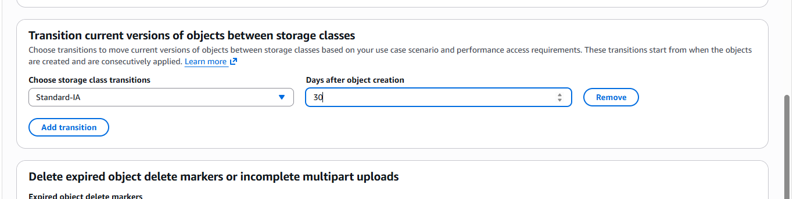
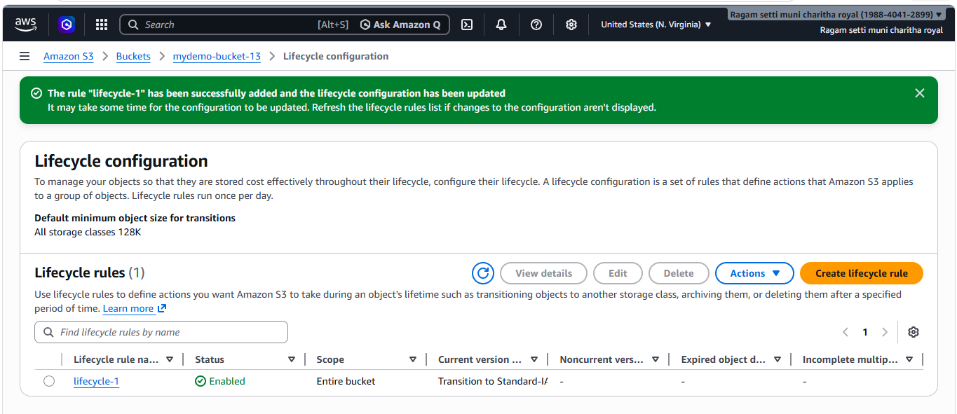
- I have verified by checking lifecycle rule
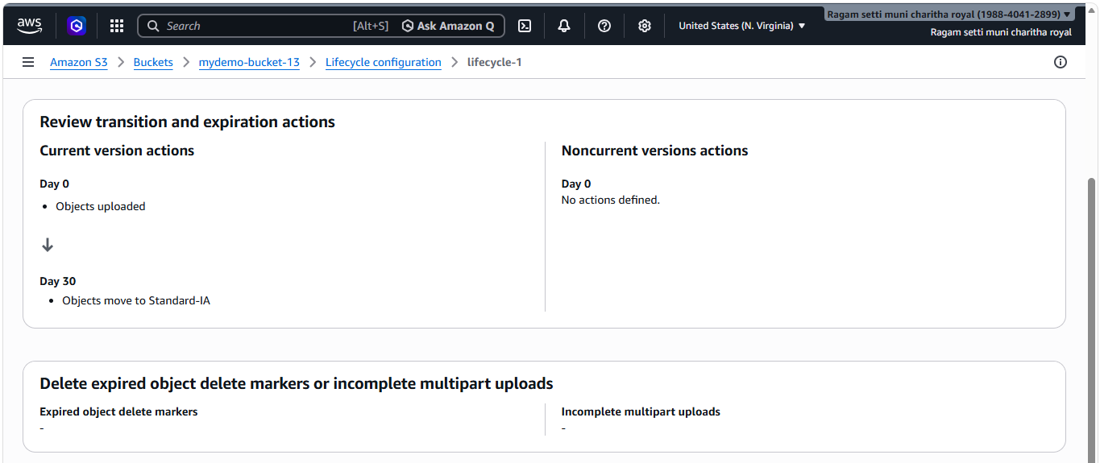
6.Push some objects to S3 using the AWS CLI.
- First I have created a txt file with some content through cli
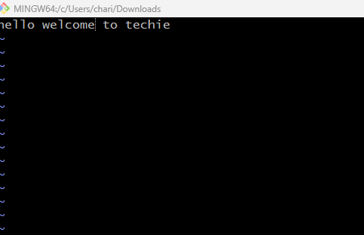
- I have copied from awscli to s3
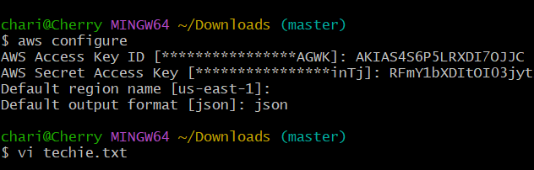
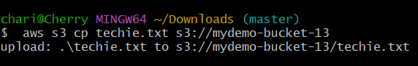
- I have checked whether the file is uploaded or not. It is uploaded successfully
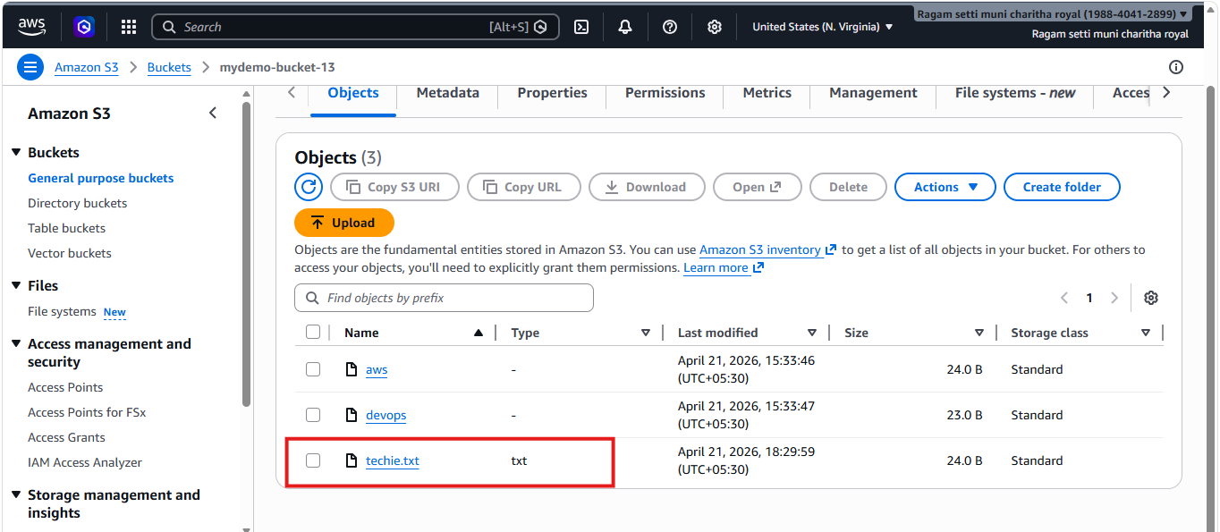
7.Write a Bash script to create an S3 bucket.
- Wrote a bash script to create a bucket
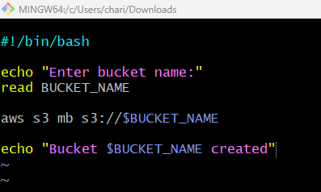
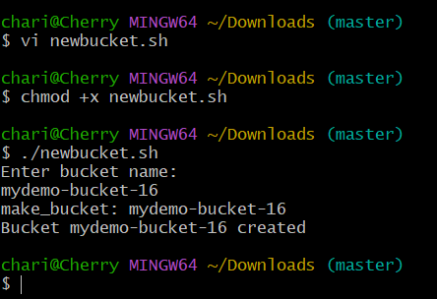
- Verified whether the bucket is created or not. Bucket created successfully
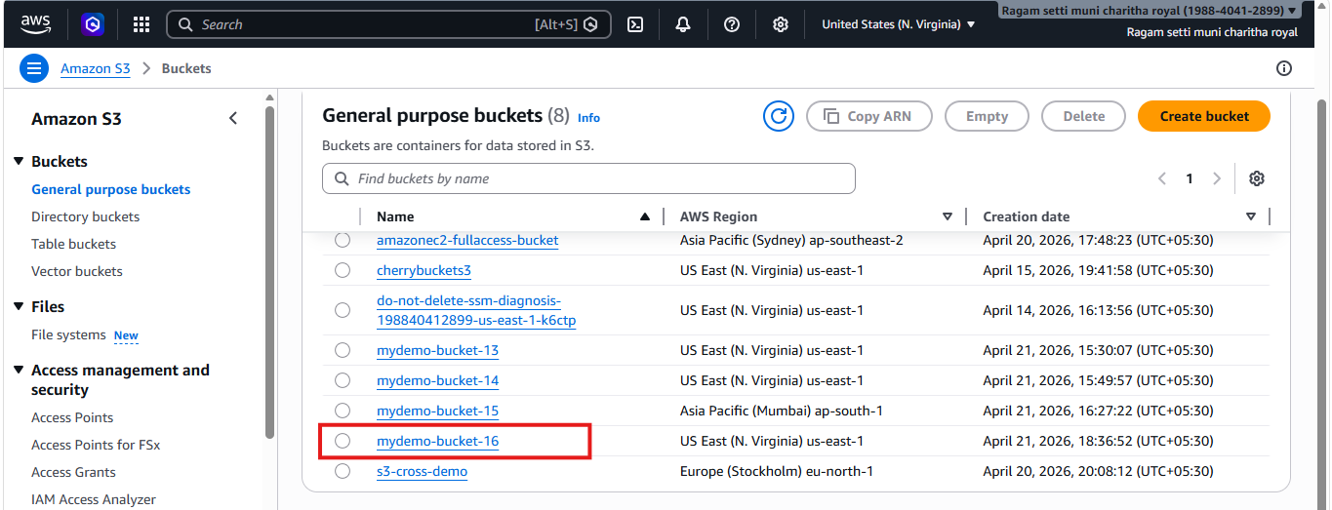
8.Upload a 1 GB file to S3 using the CLI.
- Here I am uploading 1gb file to s3 using cli.
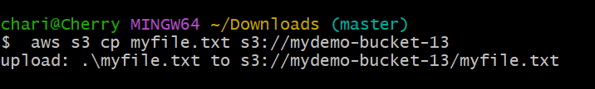
- Checked whether the file created or not. it created successfully.
